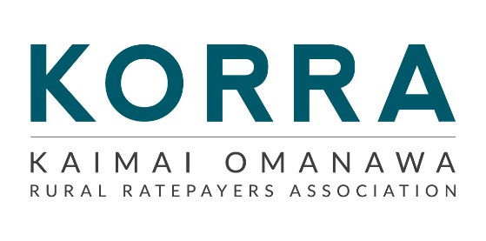

KORRA AGM Meeting Minutes
Date Thursday 7 August 2025
Chairman – Nichola James
Held in the Kaimai Hall, Commencing at 7.00 pm

Present: Nichola James (Chairperson), Gary Benner (Vice Chairman), Debbie Marshall (Treasurer), David Jones, Bryan Smith, Lorraine Weenink, Denise Kilgour, Anne-Marie Mildren, Paul Mildren, Wayne Lowry, Drew Cowley
Guest: Councillor Margaret Murray-Benge, Councillor Don Thwaites
Apologies: Councillor Tracey Coxhead, Jason and Kerry Marra

_________________________________________________________________________
Minutes:
Nichola had emailed the minutes of the last AGM.
It was MOVED LORRAINE/DEBBIE
“That the minutes of the 1st August 2024 were taken as read and confirmed as a true and correct record”
CARRIED
Matters Arising from Minutes:
At our last AGM, we gave the website a year to see if it added value to our Association; if not, we would terminate it. Gary Benner has taken over the website and made changes and updates to it. We are still unsure of the current costs, but the domain name is renewed every two years and is due for renewal in July 2026. The last invoice was $201.25. Gary was not at the meeting at this stage to clarify costs. It has improved from what it was, but there is still not a lot of action on it.

Annual Financial Statements:
Debbie presented the financial statements for the year-end June 2025
All our money is in the cheque account, and as of the 30^{th of} June 2025, we had $168.61
IT WAS MOVED DEBBIE/DAVID
“That the financial statements for the year ended 30 June 2025 be accepted”
CARRIED

Signatories:
Two signatories are required to pass payments: the Chairperson, Nichola James, and the Treasurer, Debbie Marshall. This remains unchanged.

Subscriptions:
Full Membership, with voting rights is $20 per annum. Associate Membership is $10 per membership per annum (For non-local ratepayers or tenants). This membership has no voting rights.
Do we want to increase the subscription for membership or keep it the same?
It was MOVED DEBBIE/DAVID
“That we keep the membership as status quo.”
CARRIED
Chairman’s Annual Report:
Nichola presented her report.
It was MOVED
“That my Chairperson’s report be received” NICHOLA/WAYNE
CARRIED
Election of Officers and Committee:
Chairperson –
Vice Chairperson -
Treasurer –
Secretary –
Nominations for the Chairperson were called for – no one showed any interest in taking on the position.
It was MOVED NICHOLA/DAVID
“That this meeting defers all elections until late November for a special general meeting”
CARRIED
Points for discussion at the Special General Meeting:
- Elections of Officers and committee
- Dispute Resolution Procedure: Due to the new Incorporated Societies Act 2022, the Association is required to reregister before April 2026. To meet the new requirements, we are required to add a Dispute Resolution Procedure to our constitution, which requires being passed at the AGM or Special General Meeting. Nichola has used the template provided by the NZ Companies Office to create one. This has been forwarded to the executive committee for approval.
- Distribution of surplus assets: Our society must nominate one or more not-for-profit entities to which its surplus assets may be distributed if it is liquidated or removed from the register – we may name a class or description of not-for-profit entity (preferably those with a similar purpose).
- Formalise our membership commencement date: Our Constitution states under clause 8. c) The membership year commences on the 1st of July in the financial year. Of which the member’s initial membership payment is received. No refund will be given if the membership is cancelled. We have discussed during our committee meetings changing the date from July 1st to January 1st to help with record-keeping. Do we want to formalise this date and amend our constitution?

General Business:
A discussion took place on how the new community boards will work and whether we need to continue with KORRA. Margaret said we will lose our voice if we go. It’s great having people she can call upon when required as a Councillor.
Other committees are having the same issues with not having anyone willing to take on the officer positions and the current members standing down.
Margaret thanked the committee for the work they do with the Councillors. We still have work to do with our SH29 intersections. Once funding becomes available, the design can proceed.
CCTV Camera Fund:
New funding applications through the WBOPDC open in September – Suggestions for locations were sought, and the reason why? Wayne suggested the intersection of Ruahihi Road.
KORRA Promotion:
Wayne Lowry offered to help spread the word to our community that KORRA is seeking new office holders to maintain the Association.

Meeting Closed:
With no further business, the meeting closed at 8.30 pm.

CHAIRPERSON / / 2026

